**Cambridge Institute of Technology**

K.R. Puram, Bengaluru – 560036

**Department of COMPUTER Science & Engineering**

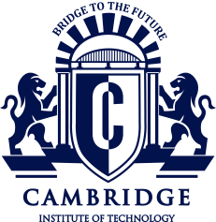

**CERTIFICATE**

Certified that **Mr. Bhupendra Saud** and **Mr. Sunil Gyawali** bearing USN **1CD19CS032, 1CD19CS167,** respectively are bonafide students of **Cambridge Institute of Technology,** has successfully completed Mini Project entitled **“Smart Village”** in partial fulfillment of the requirements for VI semester **Bachelor of Engineering** in **Computer Science and Engineering** of **Visvesvaraya Technological University, Belagavi** during academic year 2021-2022. It is certified that all Corrections / Suggestions indicated for Internal Assessment have been incorporated in the report. The Mini Project report has been approved as it satisfies the academic requirements in respect of Mini Project Work prescribed for the said semester.

**Internal Guides: Head of the Dept.**

**1) Mr. Rajesh Kumar S Dr. Shashikumar D. R.**

**Dept. of CSE., CiTech. Dept. of CSE., CiTech.**

**Examiners:**

1. **2)**